**Custom ESC for BLDC motor**

Design and implementation

**___________________________________________________________________________**

The purpose of this project is to create an electronic speed controller for a brushless motor which would be capable of precise control of the motor’s rotation speed and providing feedback information concerning the state of a motor to avionics.

Szymon Rzążewski, Jakub Mnich– MikroCpp (Universal Flying Platforms)  **//** **NOT FINISHED //**

1. **Motivation**

There are many Electronic Speed Controllers (ESC) available on the market which are designed to use with non-autonomous RC multirotors. These ESCs have good parameters but they are all driven with PWM signal which dictates output power directed to the motor and provide the flight controller with no feedback whatsoever. While this is good enough for RC flying where pilot controls the thrust with a throttle it would not work for an autonomous copter which might, in some cases, require very precise control over its drive in order to maintain flight stability in unfavorable weather conditions or during complex maneuvers.

1. **Project objectives**

Designed regulator is required to have the following features:

* Two possible communication channels: via UART and I2C. Communication way is set when device boots with a solder jumper. This feature is very important for ensuring reusability of the device in future projects.
* Sensorless commutation. ESC is required to operate with wide range of motors without any modifications. This cannot be achieved if it needs additional encoders of Hall sensors for operation.
* Dimensions smaller than 6x6cm. Device needs to be easily fitted into designed copters.
* Comfortable flat heat sink installation on main transistors.
* Ability to handle high currents: up to 25A and voltages up to 18V.
* Ability to measure current used by the motor.
* Ability to provide precise information on rotation speed to the avionics.

Designing an ESC with all above features would enable the team to build relatively advanced UAV faster and without making any makeshift changes to off-the-shelf devices which might significantly increase the chance of a fault during flight.

1. **Tools and materials**

// KiCAD, ATmega, Atmel Studio, potem: wybrane tranzystory z oszacowaniem maksymalnej mocy układu, ACS711. ODWOŁANIA DO WSZYSTKIEGO ,najlepiej specyfikacje, strony producenta//

1. **Electronics design**

// odwołanie do tutoriala Dondu, screeny ze SPICE z opisem jeśli chcesz, brak cyny na ścieżkach żeby zwiększyć dopuszczalny prąd, zworka do obejścia ACS711 żeby obniżyć koszty wykonania //

1. **Software**

// opisz swój software – tylko nie wklejaj nic poza najbardziej krytycznymi kawałkami kodu. Kod formatuj tak jak w moim dokumencie FFDE. //

1. **Basic tests**

// przetestowanie działania wszystkich obsługiwanych komed (najlepiej przez UART z przejściówką z USB żeby się nie kopać z RPI), zmierzenie maksymalnego obsługiwanego RPM – być może nie wyrobi się z komutacją dla wysokich obrotów. //

// ENJOY! //

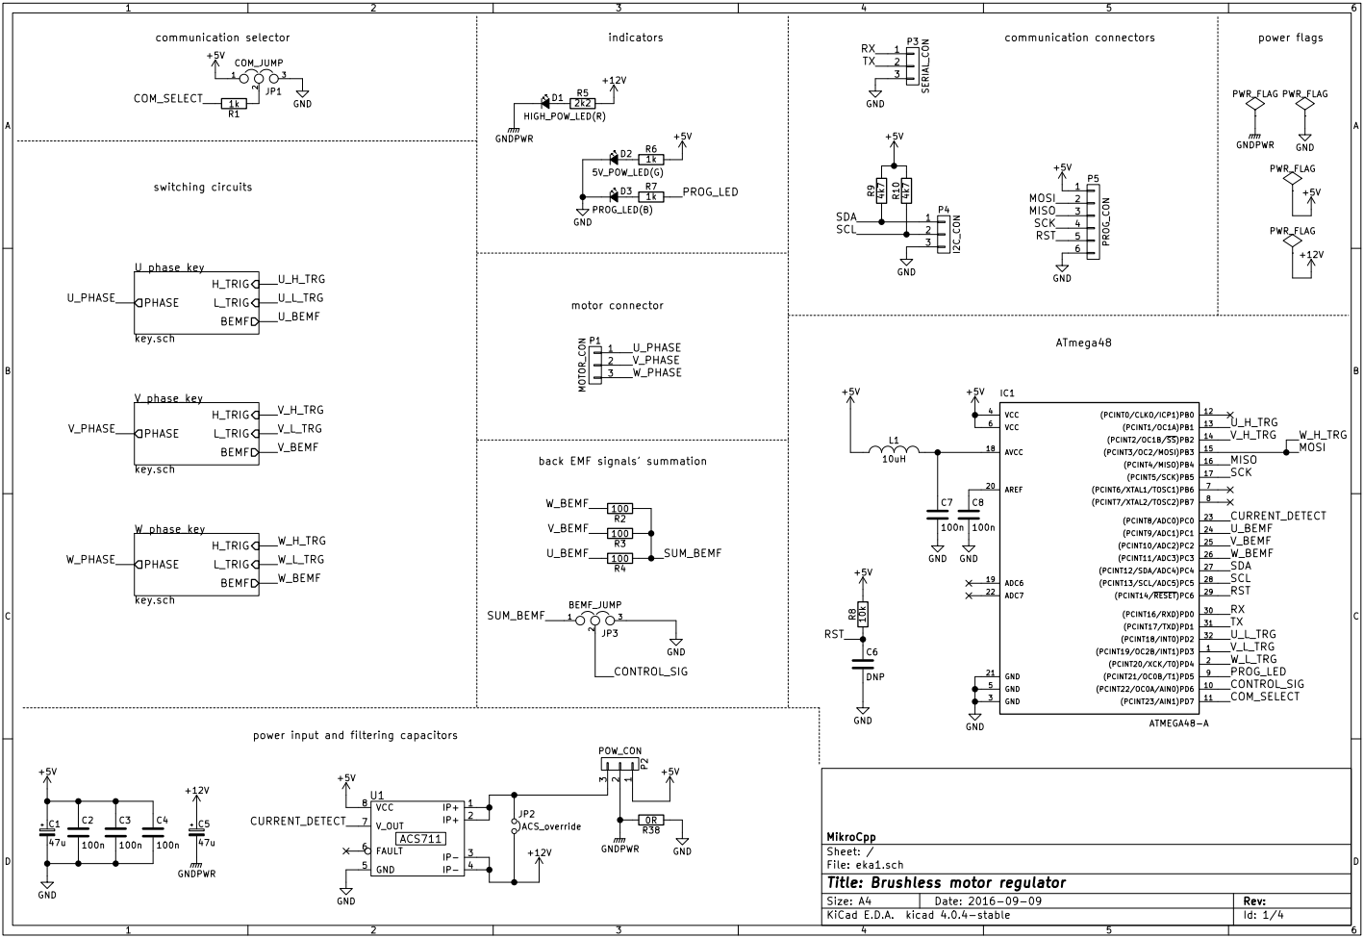

Fig. - main sheet of schematic

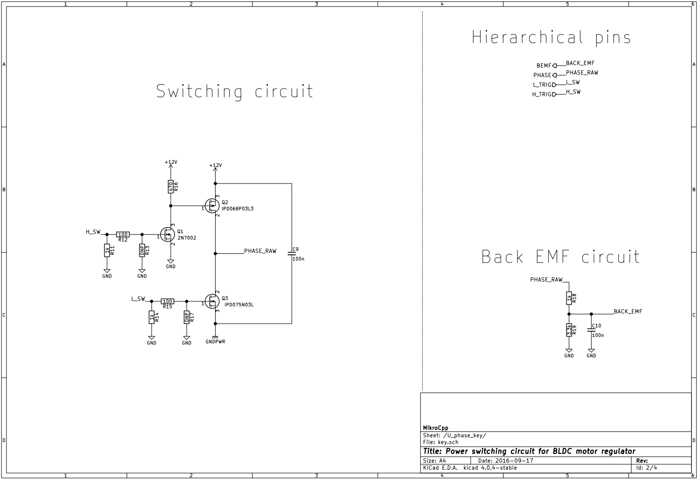

Fig. 2 - one of three identical current switches with accompanying circuitry

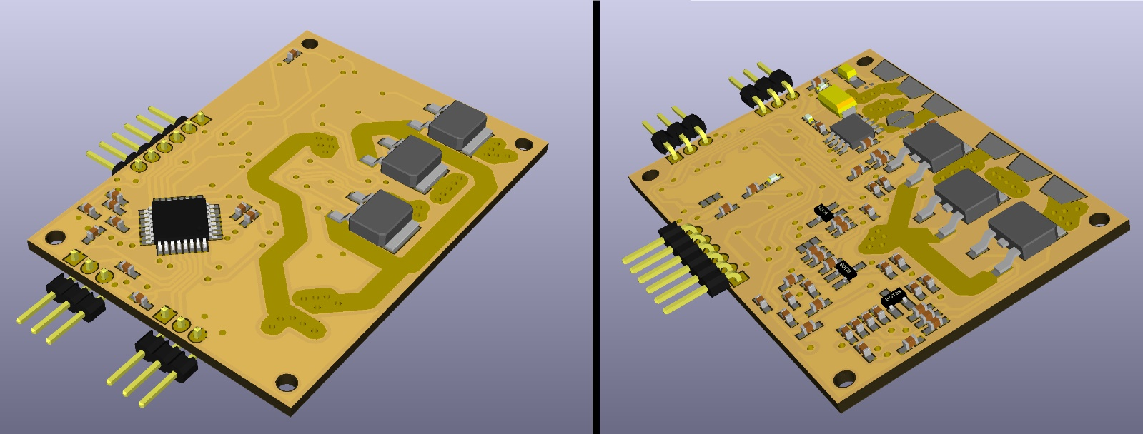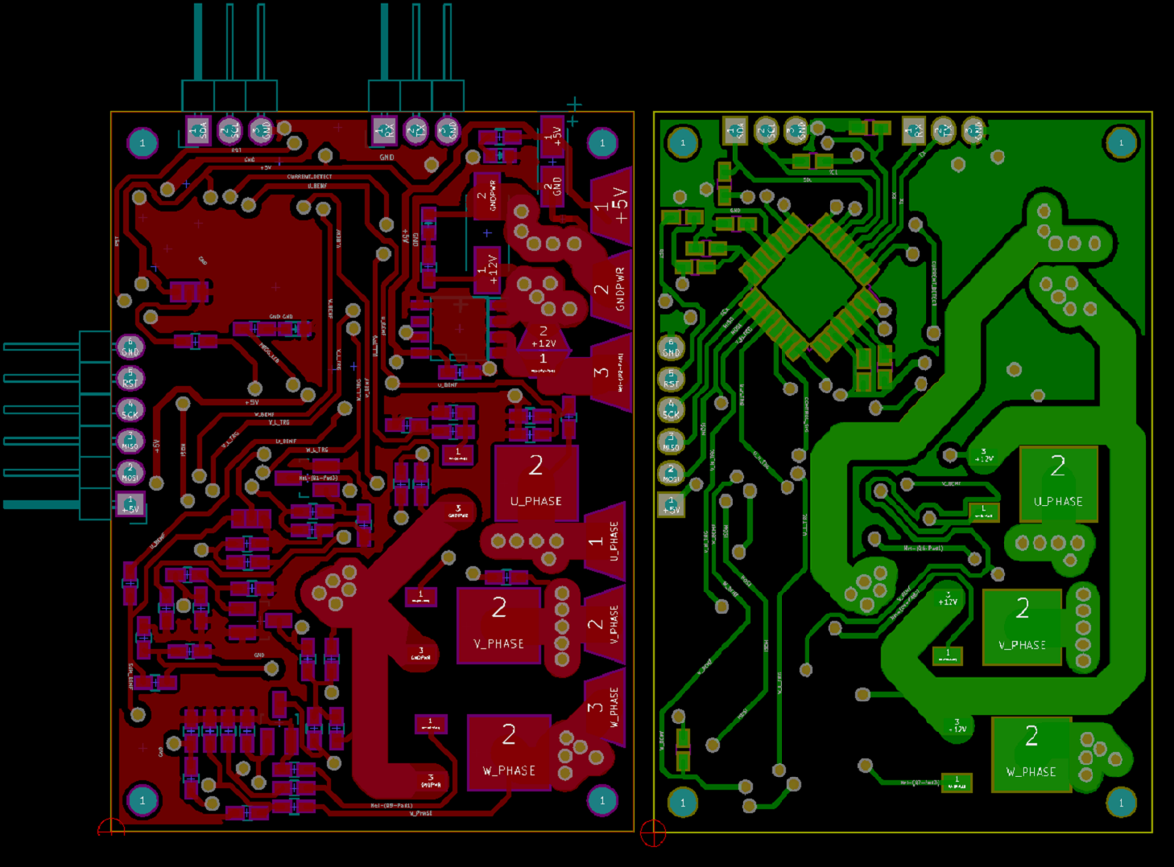

Fig. 4 - 3D visualization of PCB

Fig. 3 - printed circuit board design (top / bottom)

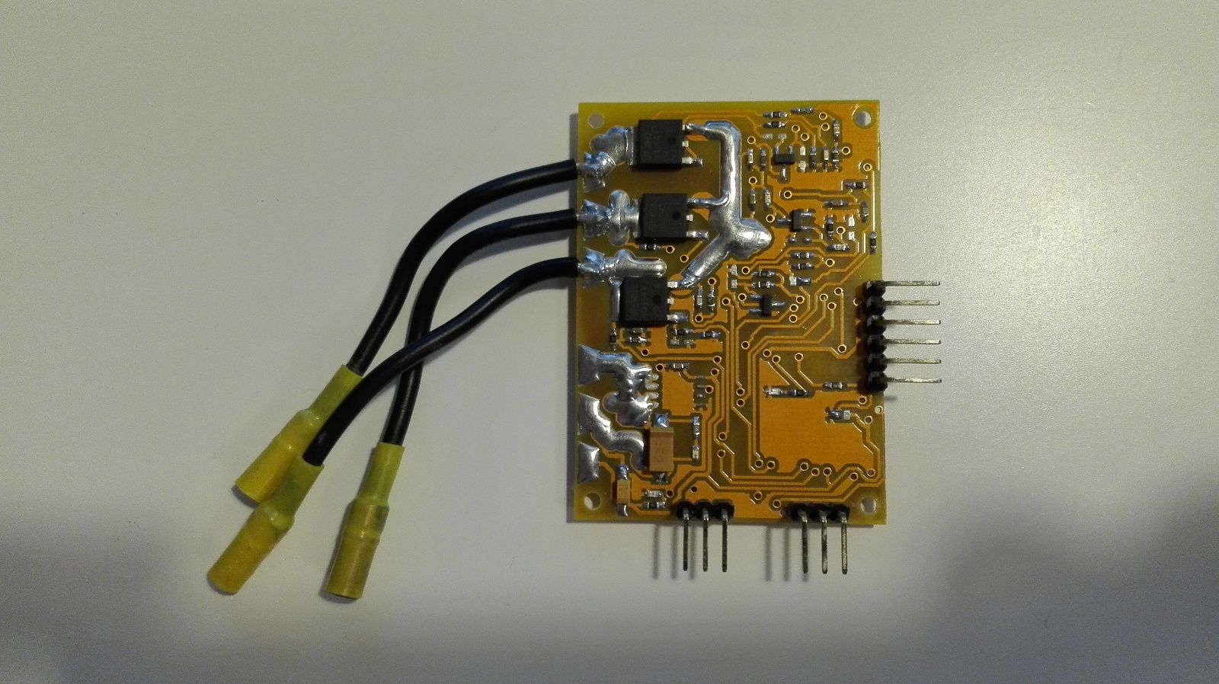

Fig. 5 - assembled device

**References:**

1. **Authors** (year) Title. *Source*
2. Title [link]